Mykel Koblenz – 9146903

COMP804 Assessment 3

GIT Screenshots

Task 2 (end of day commit)

Git status

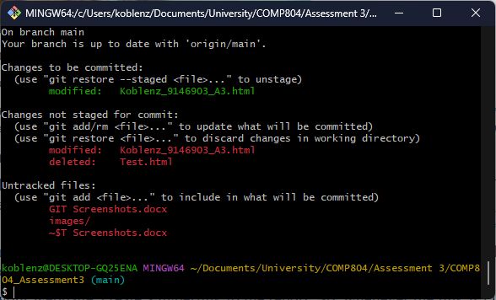

Git add .

Git status

Git commit -am “Commit 20240813”

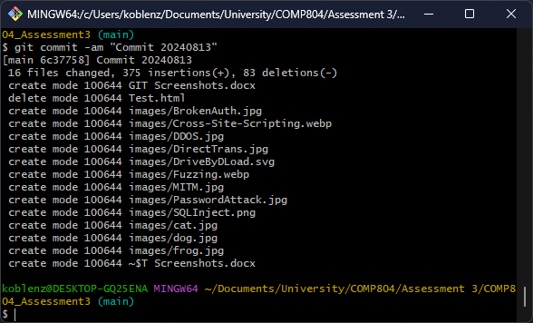

Git status

Git push

